Meta Title:
Used Cars UAE | Luxury Pre-Owned Vehicles & Fair Pricing

Meta Desc:
Drive home a UAE-approved used car! Rigorous inspections, fair pricing, and dealer-direct negotiations. Start your search now with Mukhtar Car Auctions.

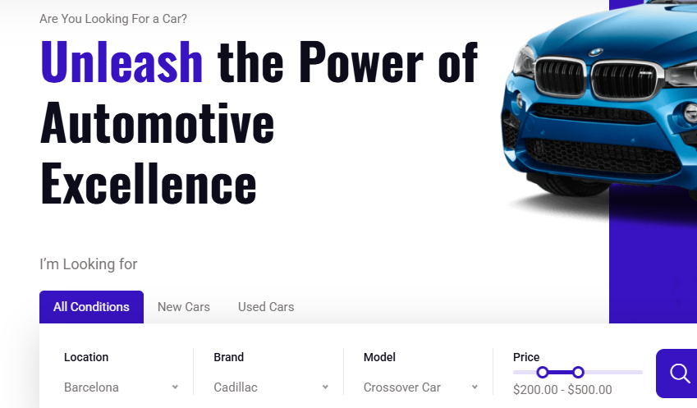Are You Looking to Buy Used Cars in the UAE?
- Welcome to the World of Luxury Automobiles
- Own the UAE's Roads Without Breaking the Bank
- Drive Your Dream Without the Price Tag
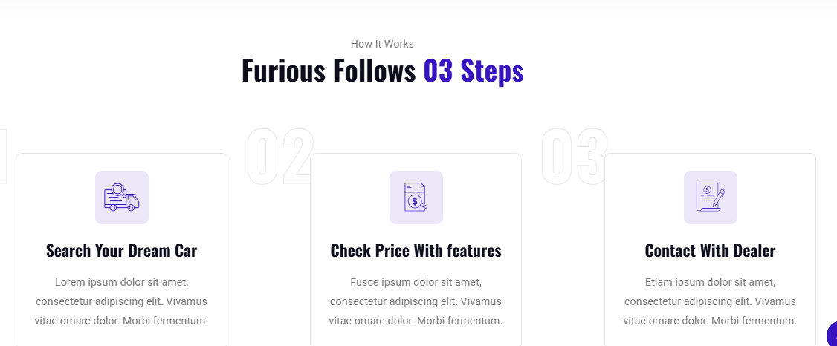How It Works

Our Simple & Transparent Process
Find Your Match | Know What You Pay | Seal the Deal
From Mercedes-Benz to Cadillac Escalade, explore 500+ rigorously inspected used cars in UAE. | See upfront pricing, repair history, and 360° virtual tours before buying any used car in UAE. | Chat directly with dealers of Mukhtar Car Auctions for test drives or instant offers to buy.

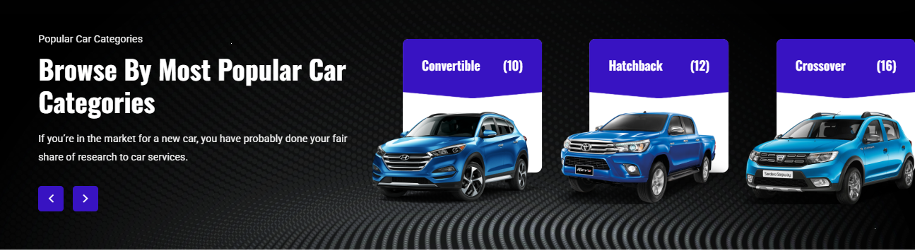Popular Car Categories

Browse By Most Popular Car Categories
Browse UAE’s favorite models like Premium Mercedes SUVs, fuel-efficient Toyota sedans, business-ready Toyota Corolla, rugged Nissan, and sporty Mitsubishi Eclipse. Find your fit fast.
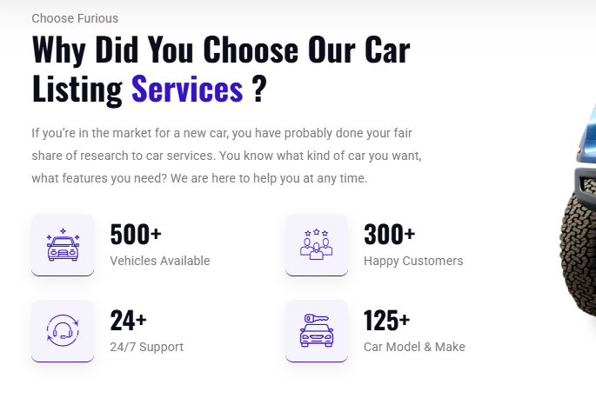Choose Mukhtar Car Auctions

Why Choose Us to Buy Cheap Used Cars in the UAE?
We cut the stress of buying used cars in the UAE. Every vehicle passes a 150-point check, comes with fair pricing guarantees, and includes warranty options. Trust drives our process.
Join Our Dealer Network

Want to Become a Dealer With Mukhtar Car Auctions?
List your inventory on UAE’s fastest-growing platform! Access qualified buyers, competitive fees, and dedicated support. Grow your business with Mukhtar Car Auctions.
Become a Dealer

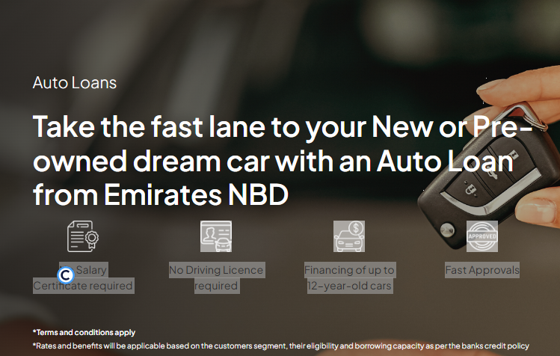Own Cars In UAE Without Bank & Down Payment
Skip the bank queues and upfront costs. Mukhtar Car Auctions empowers you to buy used cars in Dubai UAE, directly, requiring no bank loan and 15-25% down payment. Drive away in your chosen quality vehicle today, simplifying ownership. Explore our vast inventory and own your dream car without traditional financial hurdles. Start your journey now.

No Salary Certificate required | No Driving Licence required | Financing of up to 12-year-old cars | Fast Approvals

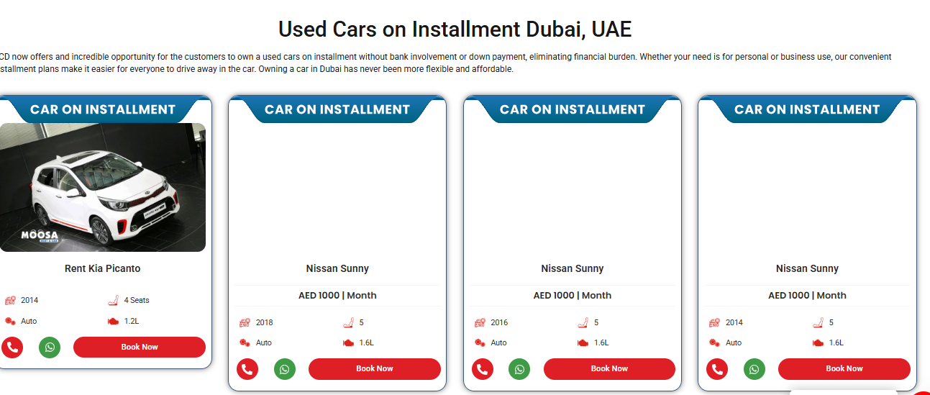Used Cars on Flexible Installments in UAE
Find your ideal used car in Dubai with payment plans customized to your budget. Mukhtar Car Auctions offers used cars on flexible installments, making quality vehicles genuinely accessible. Whether you're looking for the best used car to buy in Dubai or aiming to buy cheap used cars in Dubai, our manageable terms put you in the driver's seat.

Car Model | Year | Total Price (AED) | Down Payment | Remaining (AED) | Monthly Installment (AED) | Loan Period | Kilometers
TOYOTA FORTUNER | 2018 | 139,000.00 | 15% (20,850.00) | 118,150.00 | 3,281.94 | 36 months | 52,000
KIA KS LXS | 2022 | 81,200.00 | 25% (20,300.00) | 60,900.00 | 2,537.50 | 24 months | 71,784
NISSAN ALTIMA S | 2023 | 79,750.00 | 25% (19,937.50) | 59,812.50 | 2,492.19 | 24 months | 33,600
LEXUS IS300 | 2018 | 71,050.00 | 25% (17,762.50) | 53,287.50 | 2,220.31 | 24 months | 46,000
FORD EXPLORER | 2016 | 69,600.00 | 25% (17,400.00) | 52,200.00 | 2,175.00 | 24 months | 130,000
MERCEDES BENZ CLA 250 (4MATIC) | 2017 | 75,000.00 | 25% (18,750.00) | 56,250.00 | 2,343.75 | 24 months | 96,500
NISSAN SENTRA | 2020 | 50,750.00 | 25% (12,687.50) | 38,062.50 | 1,585.94 | 24 months | 52,000
TOYOTA CAMRY | 2017 | 47,850.00 | 25% (11,962.50) | 35,887.50 | 1,495.31 | 24 months | 240,000
MITSUBISHI MIRAGE G4 Es | 2022 | 47,850.00 | 25% (11,962.50) | 35,887.50 | 1,495.31 | 24 months | 14,085


UAE’s confident choice for used cars. Quality checks, honest deals, and a real support drive.

